How to Order SB Hats

QM has secured an embroidery shop in Long Beach to do our club hats. You buy your own cap [Wal-Mart has red baseball adjustable caps for $2.50] then give the cap to me and I will take it in to be finished. Turnaround time is about 3-days to
1-week. The caps will have our "SB" logo and chapter name on the front. And you can have your first name or "Royal" name on the back. [Remember though the longer the name the smaller it will be to fit properly.] I did for only $5 more. [Plus the cost of the hat]"Name the Game" will keep our info for anyone in the future that wishes to order a hat.
[I do have 2 extra caps at this time]

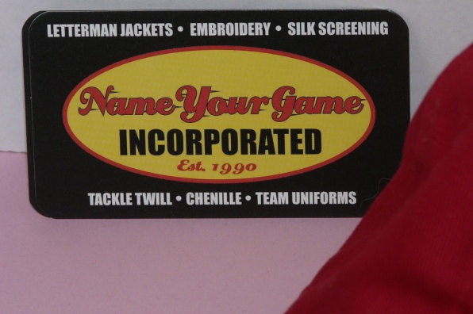
Here's how to order:
1. Buy a hat "red" baseball cap style or ask QM if she has any more left?
2. Give it to the QM with your name details
(They have it on file /font, size, and color)
3. Pay QM the $18.00
4. Your SB hat should be ready in about 1 week
5. QM will then let you know when it’s ready for you to pick-up or

you can pick it
up at the next event.
That's it! Easy-Peasy!!!

